CHAPTER 7
SYSTEM CHANGEOVER

Introduction
- Once the software is thoroughly tested and all known errors have been removed, the software, along with associated hardware, is deployed at site for use by the intended users.
- At this stage, the old system (manual system in most cases), if any, is phased out and the new system is phased in.

Changeover Operations
The changeover process normally involves the following operations:
- Imparting system and user training.
- Replacing old procedures.
- Replacing devices.
- Defining roles of different members.
- Data conversion.

Imparting system and user Training
- The system training is imparted to those who will be responsible for managing and maintaining the system.
- The user training is imparted to those members who will be affected by the system and/or using the results produced by the system.
- Anyone else who will be affected by the new system should also receive some training to become familiar with the changes.

Replacing Procedures
- This involves replacing all old operation procedures by new ones.
- This may involve discarding old forms, manual registers, etc.
- This involves replacing all old input and output devices with those of the new system.

Defining Roles
This involves defining roles of different members, and assigning the responsibilities to them as per the requirements of the system.

Data conversion
- This involves converting data in all currently existing files into a form acceptable to the new system.
- This may involve inputting of data stored in manual registers and hard-copy files, through the input devices of the new system.
- It is important to consolidate the files and eliminate duplicate records in them, while converting them to the new form.
- File inconsistencies or any errors in existing files must also be detected and removed.

Changeover Methods/Strategies
The three normally followed methods to carry out the changeover process are:
- Immediate changeover.
- Parallel run.
- Phased Conversion.
- Pilot.

Immediate Changeover
- A suitable cut-off date is decided and the new system is put to operation from that day onwards, while the operation of the old system is completely abandoned from the cut-off date.
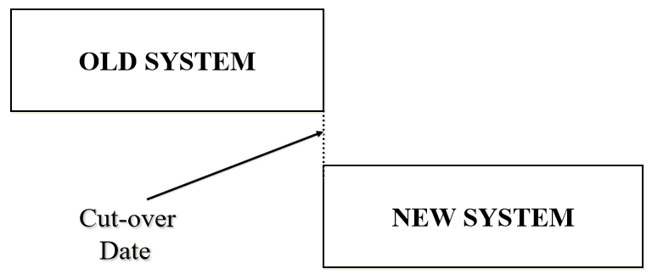

- Most systems pose some problem during the changeover process.
- Hence, this method is generally considered to be risky, because any failure in the new system during the changeover may cause total breakdown of those operations of the organization, which are related to the new and the old system.
- The work cannot progress at all, because the operation of the old system has already been stopped.
- However, this method is preferred in those situations where available manpower and changeover time is less, and the system is not so critical that some problem during the changeover process would lead to a disaster.
Parallel Run
- Both the old and new systems are operated in parallel with the same data for the initial three or four cycles.
- During this overlapping period of complete operation of the two systems, the results produced by the two systems are compared to develop confidence in the new system.
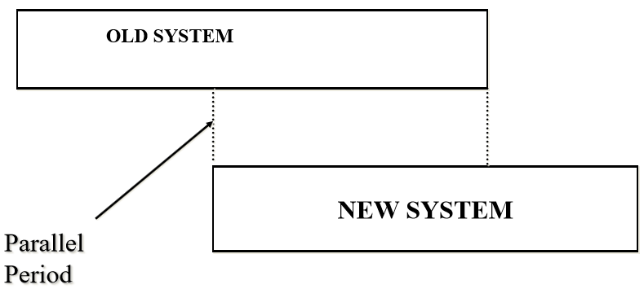
- Some discrepancies may be discovered.
- Often, these are due to inaccuracies in the old system that were not recognized before as inaccuracies.
- Some discrepancies may be due to missing program logic for which no programming was provided, or due to mistakes in the programming itself.
- These must be corrected by further debugging, before the conversion is complete.
- This method is one of the safest ways to deploy a new system, because of the availability of the old system as backup.
- There is no interruption of work if there are problems with the new system, because the old system is still in operation, and the problems found in the new system can be corrected while the old system is still being used.
- However, this method is expensive, because additional manpower is needed during the overlapping period for the operation of two systems in parallel.
- Due to this, the organization is under considerable strain during the period of parallel operation, and organizational breakdowns tend to occur, if the period of parallel operation is long.
- Continuing the two systems for long is a sign of weakness in the new system.
- This method is not preferred in situations where manpower resource is scarce.
- It is also not used in situations where the new system differs to a great extent from the old system in its functions, and its input and output.

Phased Conversion
- The complete changeover to the new system takes place incrementally over a period of time.
- The new system is gradually implemented part by part, and the old system is gradually phased out.
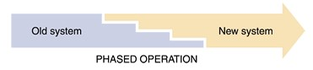

Phased Changeover
- The results produced by each part of the new system are compared against the results of the old system.
- Any discrepancies or errors found are checked and removed.
- Once confidence is developed in a particular part of the new system, that part of the new system is phased in, and the corresponding part (operations) of the old system is phased out.
- This approach is continued for each and every part of the new system.
- Hence, over a period of time, the new system is gradually phased in, while the old system is gradually phased out.
- This method is not as expensive as the parallel run, because the changeover process being gradual can usually be handled with existing manpower.
- There is no danger of interruption of work if there are problems with the new system, since the corresponding part of the old system is still in operation.
- However, it cannot be used in situations where the time period supplied for conversion process is very less, or when the new system is significantly differs from the old system.

Pilot Changeover
The group that uses the new system first is called the pilot site
The old system continues to operate for the entire organization
After the system proves successful at the pilot site, it is implemented in the rest of the organization, usually using the direct cutover method
Pilot changeover is a combination of parallel operation and direct cutover methods
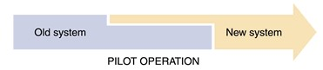

System evaluation
- Once the new system is implemented and put to operation, it is necessary to evaluate the system to verify whether it is meeting its objectives.
- These objectives are clearly stated during its problem analysis and system planning phase.
- The post implementation evaluation is normally carried out by people who have an independent viewpoint, and are not responsible for the development and maintenance of the system.
- The following points are considered when evaluating a system:
  - Performance Evaluation.
  - Cost Analysis.
  - Time Analysis.
  - User Satisfaction.
  - Ease of modification.
  - Failure Rate

Performance Evaluation
- The performance of the new system is evaluated and compared with the performance of the old system.
- Generally, the new system should be at least as efficient as the old one in performance.
- In case of any slack, the reason is analyzed, and if possible, necessary changes are incorporated in the new system to rectify it.

Cost Analysis
- It should be analyzed whether the cost estimate done for the various phases of the project, during the planning phase in the beginning, matches with the actual cost incurred in each phase.
- This knowledge can be used in making correct cost estimates for the new systems, which will be designed in future.

Time Analysis
- It should be analyzed whether the time estimate done during the various phases of the project, during the planning phase in the beginning, matches with the actual time taken in each phase.
- In case of discrepancies, the time analysis will help in finding out reasons.
- This knowledge can be used in making correct time estimates for the new systems, which will be designed in future.

User Satisfaction
- It should be found out whether the users are satisfied with the new system.
- How useful is the system for them?
- How enthusiastic are they about the service they receive?
- Do they receive outputs in time to take necessary action?
- The morale of people using or affected by a system is a good measure of the success of the system.

Ease of Modification
- Sooner or later, all systems need to be modified due to one or more reasons.
- Hence, the ease with which a system can be modified to incorporate the suggested changes is also an important parameter to judge the quality of the system.

Failure Rate
- The quality of a system also depends on its failure rate.
- A system, which frequently fails cannot meet its objectives successfully.
- Hence, it is of poor quality.

